**`The Superior University, Lahore**

Faculty of Computer Science & IT

**Computer Networks – Spring 2023**

**Lab Task Week 11**

**Name: Zunaisha Noor**

**Roll Number:biet-f21-049**

**Section: IET (A)**

**Static Routing**

1. First write your roll number in a single digit

* Roll no. is 49 🡪 4+9=13
* 13 is odd number
* 13* 2 = 26
* 26
* Every Network contain 26 PC

1. Designed Network

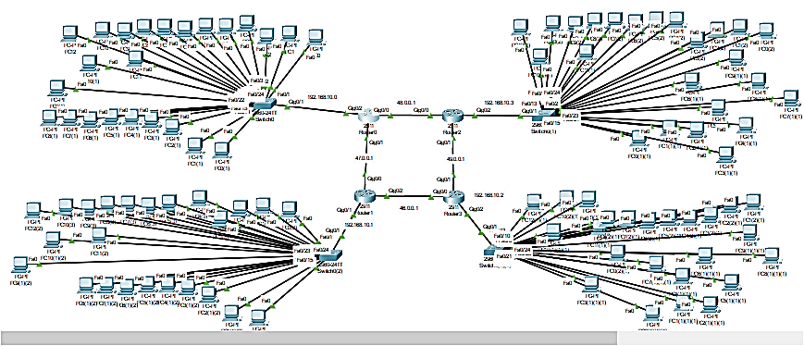

1. **IP Plan**

Ip Addresses

1. Router A: 192.168.0.1/24
2. Router B: 192.168.1.1/24
3. Router C: 192.168.2.1/24
4. Router D: 192.168.3.1/24

